# CHAPTER 1

**INTRODUCTION TO COMPOSITES**

Since the dawn of civilization, the strong and light material as always determined mankind for typical applications. The idea of combining two or more materials resulting in a new material with improved property exists from ages.

It was discovered long ago that composite material have the combined advantages with superior performance compare to each individual material from time memorial man has been using fibres along with binder or matrix for stronger materials.

Over the last thirty years, composite materials, plastic, ceramics have been the new entrants, which have developed gradually and often served as replacements for metal in certain cases the volume a number of applications of composite material has grown steadily, penetrating and conquering new markets relentlessly.

Modem composite constitute a significant proportion of the engineered materials market ranging from everyday products to sophisticated rich applications.

A composite material is a material system composed of a mixture or combination of two or more micro or macro constituents that differ in form a chemical composition and which are essentially insoluble in each other.

The engineering importance of a composite materials is that two or more distinctly different materials combine together to form a composite material which possesses properties that are superior or important in some other manner to properties of individual components.

**The main components are:**

1. Dispersed phases or fiber phase
2. Matrix phase

The fibers particulates and whiskers act as the reinforcement and provide one of the stiffness and strength. The matrix binds the reinforcement together thus affecting the used to reduce the cost and improve possibility and dimensional stability. The matrix is also used to product the weak fiber from surface damage.

**1.1 Need of composites**

1. Tensile strength of composites is four to six times greater than that of steel of aluminium
2. Improved torsional stiffness and impact properties
3. Composites have higher fatigue endurance limit (up to 60% of the laminate tensile strength).
4. Composites material are 30-45% lighter than aluminium structures designed to the same functional requirements.
5. Lower embedded energy compared to other structural material like steel aluminium etc.
6. Composites are less noisy while in operation and provide lower vibration transmission than metals.
7. Composites are more versatile than metals can be tailored to meet performance needs and complex design requirements.
8. Long life offers excellent fatigue, impact and environmental resistant and reduced maintenance.
9. Company enjoy reduced life cycle cost compared to metals.
10. Composites exhibits excellent correction and fire resistant’s.
11. Improved appearance smooth surfaces.
12. Composites part can eliminate joints fasteners, providing part simplification integrated design compared to conventional metallic parts.

**1.2 Classification of composites**

1. Based upon geometry of reinforcement.

a) Particulate reinforcement composite.

b) Flake reinforcement composite.

c) Fiber reinforcement composite.

2. Based upon matrix medium (Bonding material)

a) Metal matrix composite

b) Ceramic matrix composite

c) Polymer matrix composite

**1.2.1 Particulate reinforcement composite:**

The reinforcement medium used in this type of composite is the form of particles are immersed in matrix medium materials. Alloy and ceramics are used as matrices.

**1.2.2 Flake reinforcement composite**

Here reinforcement medium is in form of nature. Example for flake materials is glass, mica, aluminium and silver.

**1.2.3 Metal matrix composite:**

Metal is used as binding (matrix) materials in this type of composite. Examples for matrices used in this type of composites are aluminium, magnesium. The metal is reinforcement by using fiber. Carbon and silicon carbide are example for fibers used in this type of composite.

**1.2.4 Ceramic matrix composite:**

The ceramic is used as matrix medium. Alumina and calcium alumina silicate are used as matrix medium. In CMC ceramic is reinforced by fiber. Carbon and silicon carbide are used as fiber.

**1.2.5 Polymer matrix composite**

Here polymer is used as a matrix medium. Examples for are epoxy, polymer. Here polymer is reinforced by thin diameter fibers. Examples for fibers are graphite, aramid and boron.

**1.2.6 Hybrid Composite Materials**

A hybrid composite material is a combination of “hybrid” and “composite”. This is simply a hybridization of composite materials, for example, composites reinforced with two or more types of fibers or a laminar composite material consisting of fiber-reinforced metals and thin foil metals. The “hybrid” in hybrid composite materials is the hybridization in macroscopic structure in the metallographic scale.

In some cases relating to functional materials, the term “hybrid materials” may be preferable. Because structural composites such as carbon/carbon composites and metallic matrix composites have been very popular, the term “composites” may sound conventional for researchers of functional materials.

**CHAPTER 2**

**RAW MATERIALS**

Major constituents in a fiber reinforced composite material are the reinforcing fibers and matrix which acts as a binder for the fibers. Other constituent’s area coupling agents, coating and filters. Coupling agents coating are applied to improve their wetting with the matrix as well as to promote across fiber interface. Fillers are used some polymeric matrices primarily to reduce cost and improve dimensional stability.

Manufacturing of a composite structure starts with the incorporation of a large number of fibers into thin layer of matrix to form a lamina the thickness is usually in the range of 0.1-1.0 mm.

If continuous (long) fibers are used in making the lamina they may be arranged either in unidirectional orientation (all the fiber in one direction) or in a bidirectional orientation (fiber in two direction, usually normal to each other) for a lamina containing unidirectional fibers the composite materials has the highest strength modulus in longitudinal.

Direction of the fibers however in the transverse direction its strength and modulus can be varied by employing different amounts as well as different types of fibers in the longitudinal and transverse directions. For a balanced lamina these properties are the same in both direction.

A lamina can also be constructed using discontinues fiber in matrix the fibers can be arranged either in a unidirectional orientation or in a random orientation. Discontinuous fiber reinforced composites have lower strength and modulus than continuous fiber composites. However with random orientation of fibers, it is possible to obtain nearly equal mechanical and physical properties in all directions in the plane of the lamina.

The thickness required support a given deflection in a fiber reinforced composite structure is obtained by stacking several laminas in a specified sequence to form a laminate. Various laminas in a laminate may contain fiber either all in one direction or in different directions. It also possible to combine different kinds of fiber to form either interplay hybrid laminate.

An interplay hybrid laminate consist of different kind of fibers in different laminas. Here as interplay hybrid laminate consists of two more different kinds of fibers interspersed in the same lamina.

**2.1 Fibers**

Fibers are the principle constituent in a fiber reinforced composite materials. They occupy the largest volume fraction in a composite laminas and share the major portion of the load acting in a composite structure. Proper selection of the type amount and orientation of fibers is very important, since it influence the following characteristics of a composite laminate.

* Specific gravity
* Tensile strength and modulus
* Compressive strength and modulus
* Fatigue strength as well as fatigue failure mechanisms
* Electrical and thermal conductivities
* cost

**2.1.1 Glass fiber:**

Glass fibers are the most common of all reinforcing fibers for polymer (plastic) matrix composites. The principle advantages of glass fibers are low cost, high tensile, high chemical resistance and excellent insulating properties. The disadvantages of low tensile modulus, relatively high specific gravity, relatively low fatigue resistance 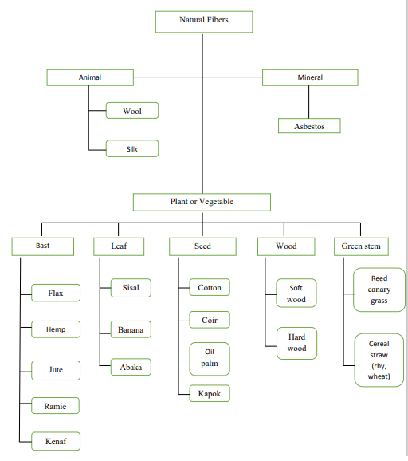and high hardness.

**2.1.2 Carbon fibers (Graphite fibers):**

Carbon fibers are commercially available with a variety of tensile module ranging from on low side to the high side. In low modulus fibers have tensile and compressive strength higher tensile strains to failure than the high modulus fibers. Among the advantages of carbon fibers is high tensile strength weight ratio as well as tensile modulus weight ratio, very low coefficient of linear thermal expansion and high fatigue strengths.

**2.1.3 Kevlar 49 Fibers:**

Its belongs to a group of high crystalline aramid (aero polyamide) fibers that have the lowest specific gravity and the highest tensile strength to weight ratio among the current reinforcing fibers. As reinforcement, they are being used in many marine and aerospace application where light weight high tensile strength and resistance to impact damage are important. Like carbon fibers they also have a negative coefficient of thermal expansion in the longitudinal direction, which utilized trended circuit boards.

**2.1.4 Extended chain polyethylene fibers:**

Extended chain polyethylene fibers, common available under the trade name spectra. Polyethylene fibers have the highest strength to weight ratio of all commercial fibers available to data. The other outstanding features of spectra fibers are of their low moisture absorption (1% compare to 5-6% for Kevlar 49) and high abrasion resistance, which make them very useful marine composites such as bold hulls and water skis. Spectra fibers provide high impact resistance for composite laminates even at low temperature such as armours, helmets etc. ballistic composites.

**2.1.5 Boron Fibers:**

The main feature boron fibers is their extremely high tensile modulus. Coupled with their relatively large diameter, boron fiber offer excellent resistance to bucking, which is turn contributes to high compressive strength for boron fiber-reinforced composite. The principle disadvantage of boron is its high cost, which is higher than that of many forms of carbon fibers. For this reason, its use is at present restricted aerospace applications.

**2.1.6 Ceramic Fibers:**

Silicon carbide (sic) and aluminium oxide (AL2O3) fibers are example for ceramic fibers. Their melting points are 2830 and 2045° C respectively. Silicon carbide retains its strength well above 650° C. Both fibers are suitable for reinforcing metal matrices.

Silicon carbide fibers are available in three different forms.

They are monofilaments, multifilament’s yarn and whiskers. Another ceramic fiber containing approximately equal parts of Al2O3 silica (SiO2), is available in short discontinuous length under the trade name fiber flax.

**2.1.7 Natural Fiber:**

Natural fibers include those made from plant, minerals sources. Natural fibers can be classified according to their origin.

1. Vegetable fibers

Vegetable fibers are generally comprised of cellulose.

Ex: cotton, flax, sisal and hemp

1. Animal fibers

Animal fibers generally comprise proteins ex: silk, wool, angora and alpaca.

**2.2 Matrix**

The role of the matrix in a fiber-reinforced composite is (1) to transfer stress from fibers, (2) to provide a barrier against an adverse environment and (3) to protect the surface from mechanical abrasion.

**2.2.1 Polymeric matrix**

A polymer is defined as a link-chain cute containing one or more repeating units of atoms, joined together by strong bonds. A polymeric is a collection of a large number of polymer modulus of similar chemical structure.

Polymer are into board categories. They are thermoplastics and thermostats.

**2.2.1.1 Thermoplastic matrix**

In a thermoplastic polymer individual more cutes are linear in structure with no chemical linkage between them. They are held in place by weak secondary bond such as vander walls bonds and hydrogen bonds with the application of heat and pressure, these intermolecular bonds in a solid thermoplastic polymer can be moved relatively to each other to flow into new position.

Upon cooling the molecules freeze in their new position, restoring in the secondary bonds between them and resulting in a new solid shape. Thus a thermoplastic polymer can be heat softened melted and reshaped as many times as desired. The molecules in these polymers contain rigid aromatic rings that give them relatively high glass transition temperatures Tg and an excellent dimensional stability at elevated temperatures. The actual value of Tg depends on the size and flexibility of other chemical groups or linkages in the chain.

Polyether, ether ketone (peek)

PEEK is a semi crystalline polymer with a maximum achievable crystallinity. Continues carbon fiber-reinforced PEEK composites are known in the industry as aromatic composite (APC). PEEK is the foremost thermoplastic matrix they replace epoxies in many aerospace the outstanding property of PEEK is its high fracture toughness and its low water absorption property.

1. Poly phenylene sulphide (PPS)

PPS is semi crystalline polymer which has relatively low Tg this due to the flexible sulphide linkage the aromatic rings. It has excellent chemical resistance.

1. Polysulphide:

Polysulphide is an amorphous thermoplastic which has a high tensile strain-t-failure and an excellent hydrolytic stability under hot/wet conditions.

Although it has good resistance to mineral acid alkalis acid and salt solutions. D) Thermoplastic polyamides:

Thermoplastic polyamides are linear polymers derived by condensation polymerization of a polemic acid and an alcohol. Depending on the types of the polymeric acid alcohol, various thermoplastic polyamides can be produced. The resulting polymer has a high melt viscosity and must be produced at relatively high temperature. Polyamide (PAI) melting are process able thermoplastic polyamide.

**2.2.1.2 Thermoset matrix:**

In a thermoset polymer, the molecules are chemically joined together by cross-links are formed during the polymerization reaction of heat and pressure.

1. Epoxy:

Epoxy resins are those most often used for advanced structural applications. They are generally two-part systems consisting of an epoxy resin and hardener which is either an amine or anhydride. The important property of this resin is it permits good adhesion between adjacent layers during assembly operations.

1. Polyester:

Polyester resins can be formulated in a verity of properties ranging from hard and brittle to soft and flexible. Its advantages are low viscosity, fast cure time and low cost. The principle disadvantages of polyesters over epoxies are their high volumetric shrinkage.

Polyester resins are unsaturated formed by the reaction of dibasic organic acids and polyhydric alcohols. Polyester resins are used in sheet molding compound, bulk molding compound and the toner of laser printers. Wall panels fabricated from polyester resins reinforced with fiberglass. So it is termed as “fiberglass reinforced plastics (FRP)”.

FRP is used in restaurants, kitchens, restrooms and other areas that require washable low-maintenance walls. Unsaturated polyesters are condensation polymers formed by the reaction of polyols (also known as polyhydric alcohols), organic compounds with multiple alcohol or hydroxyl functional groups, with saturated or unsaturated dibasic acids. Typical polyols used are glycols such as ethylene glycol; acids used ale phthalic acid and maleic acid. Water, a by-product of esterification reactions, is continuously removed, driving the reaction to completion.

C) Vinyl-Ester

Vinyl ester resins possess good characteristics of epoxy resins, such as excellent chemical resistance and tensile strength. However the volumetric shrinkage of vinyl ester resins is higher than that of the parent resins.

**2.2.2 Metal Matrix**

Metal matrix has the advantage ever polymeric matrix in applications requiring a long term resistance to severe environments, such as higher temperature. The yield strength and modulus of most metals are higher than polymers. Another advantage of using metals is that they can be plastically deformed and strengthened by a variety of disadvantages namely, they have high corrosion at the fiber/matrix interface.

The two most commonly used metal matrices are based on aluminium and titanium. Both of these metals have comparatively low specific gravities and are available in a variety of alloy forms.

**CHAPTER 3**

**LITERATURE REVIEW**

**3.1 Natural fibres**

Several researchers studied on various properties of fibres for improving its properties for the structural applications.

In recent years, the natural fibre reinforced composites have attracted substantial importance as a potential structural material. The attractive features of the natural fibres like jute, sisal, coir and banana have been their low cost, light weight, high specific modulus, renewability and biodegradability. Naturally, composites reinforced with such natural fibres have thus been a subject of intense study for low strength, low cost application in contrast to the synthetic fibre reinforced composites. Since the interfacial bond between the reinforcing fibres and the resin matrix is an important element to realize the mechanical properties of the composites, studies have been focussed on the treatment of fibres to improve the bonding with resin matrix by several authors. Amongst the several natural fibres, jute constitutes a major area of investigation.

𝐃𝐈𝐏𝐀 𝐑𝐀𝐘, 𝐁 𝐊 𝐒𝐀𝐑𝐊𝐀𝐑, 𝐀 𝐊 𝐑 𝐍 𝐑 𝐁𝐎𝐒𝐄 [𝟏] studied the effect of

Mechanical properties of jute fibre treated with alkali and it is proved that the treatment increases the flexural properties significantly.

𝐕𝐈𝐕𝐄𝐊 𝐌𝐈𝐒, 𝐒𝐀𝐍𝐃𝐇𝐘𝐀𝐑𝐀𝐍𝐈 𝐁𝐈𝐒𝐖𝐀𝐒 [𝟐] made an investigation to carry out the best use of jute fiber, a natural fiber abundantly available in India. The present work describes the development and characterization of a new set of natural fiber based polymer composites consisting of bidirectional jute fiber mat as reinforcement and epoxy resin as matrix material. The composites are fabricated using hand lay-up technique and are characterized with respect to their physical and mechanical properties. Experiments are carried out to study the effect of fiber loading on the physical and mechanical behaviour of these composites. Result shows the significant effect of fiber loading on the mechanical properties of the composites. Also, the formation of voids in the composites is an influencing factor on the mechanical properties.

**3.2 Hybrid composites**

Natural fiber composites such as sisal and jute polymer composites became more attractive due to their high specific strength, lightweight and biodegradability. But due to its low strength, less load carrying capacity several researchers investigated the properties of hybrid composites to get the best properties of both natural and synthetic fibers.

𝐌. 𝐑𝐀𝐌𝐄𝐒𝐇 , 𝐊. 𝐏𝐀𝐋𝐀𝐍𝐈𝐊𝐔𝐌𝐀𝐑 , 𝐊. 𝐇𝐄𝐌𝐄𝐂𝐇𝐀𝐍𝐃𝐑𝐀 [𝟑]made a study on hybrid composites. In this study, sisal–jute–glass fiber reinforced polyester composites is developed and their mechanical properties such as tensile strength, flexural strength and impact strength are evaluated. The interfacial properties, internal cracks and internal structure of the fractured surfaces are evaluated by using Scanning Electron Microscope (SEM). The results indicated that the incorporation of sisal–jute fiber with GFRP can improve the properties and used as an alternate material for glass fiber reinforced polymer composites.

𝐊. 𝐒𝐀𝐁𝐄𝐄𝐋 𝐀𝐇𝐌𝐄𝐃 , 𝐒. 𝐕𝐈𝐉𝐀𝐘𝐀𝐑𝐀𝐍𝐆𝐀𝐍[𝟒] made a research about the effect of stacking sequence on tensile, flexural and inter laminar shear properties of untreated woven jute and glass fabric reinforced polyester hybrid composites has been investigated experimentally. All the laminates were made with a total of 10 plies, by varying the number and position of glass layers so as to obtain six different stacking sequences. One group of all jute laminate was also fabricated for comparison purpose. Total fibre weight fraction was maintained at 42%. Specimen preparation and testing was carried out as per ASTM standards. The results indicated that the properties of jute composites can be considerably improved by incorporation of glass fibre as extreme glass plies. The layer sequence has greater effect on flexural and inter laminar shear properties than tensile properties. An overall comparison between the properties of all the laminates revealed that the hybrid laminate with two extreme glass plies on either side is the optimum combination with a good balance between the properties and cost.

**3.3 STITCHED COMPOSITE**

Stitching of composite is a technique used to decrease the stress concentration by using small amount of synthetic fibre to obtain the same amount of strength.

𝐕. 𝐍𝐀𝐍𝐓𝐇𝐀𝐆𝐎𝐏𝐀𝐋, 𝐓. 𝐒𝐄𝐍𝐓𝐇𝐈𝐋𝐑𝐀𝐌 𝐀𝐍𝐃 𝐕. 𝐑. 𝐆𝐈𝐑𝐈 [𝟓] made a research on self-reinforced composite in which self-reinforced composites were prepared from woven polypropylene tapes. The woven tapes were further stitched by lock stitch and its effects on flexural and impact properties of the composites were studied. Flexural and impact results showed that stitching parameter such as stitches per inch (SPI), sewing yarn count and direction of stitching have a significant effect on improvement of mechanical properties compared to the control sample (Unstitched sample) without stitching. The morphological studies were carried out using optical microscopy and failure mechanism was analysed.

𝐀𝐑𝐈𝐄𝐅 𝐘𝐔𝐃𝐇𝐀𝐍𝐓𝐎 , 𝐍𝐀𝐎𝐘𝐔𝐊𝐈 𝐖𝐀𝐓𝐀𝐍𝐀𝐁𝐄 , 𝐘𝐔𝐓𝐀𝐊𝐀 𝐈𝐖𝐀𝐇𝐎𝐑𝐈 , 𝐇𝐈𝐊𝐀𝐑𝐔 𝐇𝐎𝐒𝐇𝐈[𝟔]

Made research on effect of stitch density on tensile properties and damage mechanisms of stitched carbon/epoxy composites in which Experimental investigation is performed to study tensile properties, damage initiation and development in stitched carbon/epoxy composites subjected to tensile loading. Modified-lock stitch pattern is adopted, and stitch density is varied, viz. moderate density (stitched 6 _ 6: stitch density = 2.8 cm_2) and high density (stitched 3 _ 3: stitch density = 11.1 cm_2). The stitched preforms are then infiltrated by epoxy XNR/H6813 using resin transfer molding process. Tensile test is conducted to obtain in-plane mechanical properties (tensile strength, failure strain, tensile modulus and Poisson’s ratio). Effect of stitch density on the mechanical properties is assessed, and it is found that stitched 3 _ 3 modestly improves the tensile strength by 10.4%, while stitched 6 _ 6 reduces the strength by only 1.4%. In stitched 3 _ 3 cases, the strength increase is mainly due to an effective impediment of edge-delamination. Tensile stiffness and Poisson’s ratio of carbon/epoxy are slightly reduced by stitching. Damage mechanisms in stitched and unstitched composites are studied using acoustic emission testing and interrupted test coupled with X-ray radiography and optical microscopy. The detailed damage observation reveals that stitch thread promotes early formation of transverse and oblique cracks. These cracks rapidly develop, and higher density of cracks ensues in stitched composites.

From the above survey it is clear that natural fibres are the abundantly available one having low cost, light weight, high specific modulus, renewability and biodegradability. But due to some disadvantages such as poor durability, low strength, less fatigue it forces the uses to go for synthetic fibres. But as far as synthetic fibre is concerned, though it has higher strength and fatigue properties it lags in biodegradability and economic wise and it causes land pollution. Since these two have both merits and demerits a new concept enters which is nothing but Hybrid composites.

In hybrid composites the best feature of both natural and synthetic fibres are taken. But when the amount of synthetic fibre is increased in the total weight the strength of the combination will surely increases.

In our project, we made a hybrid composite of jute and polyester. But special technique of localised hybridisation technique is involved in it. This ensures that the synthetic fibre should be implemented only in the area where stress concentration is maximum. So , the by hybridising only the small amount of synthetic fibre with natural fibre maximum strength is obtained and it is proved that its strength is equivalent to the sample in which there are ten layers of laminates of jute and polyester.

**CHAPTER 4**

**METHADOLOGY**

Fabrication

Testing

Designing

Fabrication

Testing

Comparing

Natural fiber specimen with

circular holes

Testing in UTM machine

Natural and composite material

with stitches around the holes

Comparison of stacking sequence

and stitching

Natural fiber specimen with

various stacking sequence

Testing in UTM machine

Plot the results

**CHAPTER 5**

**SPECIMEN DESIGNING**

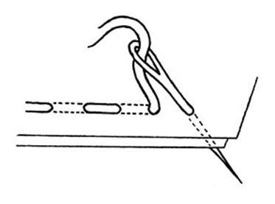

Delamination at the interface between the adherents or between the layer of laminates is the typical form of failure in bonded or co-cured composite joints as a consequence of the high peel and shear stresses which develop at the joint ends and of the low through-thickness strength of laminates. The insertion of through-thickness reinforcement, achievable by stitching or with the incorporation of metallic or fibrous short rods (Z-fibers), has proved to be a particularly efficient method to improve the inter laminar properties of laminates. The significant increases observed in the fracture toughness, inter laminar fatigue resistance, impact damage tolerance and compression after impact properties of stitched or Z-fiber reinforced laminates are mainly due to the bridging effect of through-thickness reinforcements, which reduces the driving force at the crack tip, thereby suppressing or delaying the propagation of delamination’s. And all of them consistently indicate large increases in the durations of stitched joints as compared to those of conventional joints.

Because of the scarcity of detailed experimental observations and of the number of variables involved (stitch material, density and pattern of stitching, adoption of prepare or preform laminate, stacking sequences of laminate adherents, etc.), a complete understanding of the physical mechanism of stitching and of its role.

**5.2 SAMPLE PREPARATION FIBER:**

FIBRE: Woven Jute (Mat Form)

MATRIX: Unsaturated Polyester

1. The jute fiber will be in the form of Mat. The Mat is made of warp and weft arrangement.
2. The Warp is load carrying medium and the weft is load distributing medium.

Here jute fiber is used for fabricate the natural fiber composites. The natural fibers are cut in the length of 300 mm, 125 mm and 3 mm by scissor and various stitches were done by manually.

A known weight of SFs of definite length was randomly spread between two mild steel plates, Extreme care was taken to obtain a uniform distribution of fibers. A load 40 metric tons was applied on the mild steel plates by hydraulic compression to form a single sheet. This compressed sheet was placed in mould with a size of 300 mm × 125 mm × 8 mm. Then, 97.5% of saturated polyester resin was mixed with 2% MEKP (catalyst) and 0.5% cobalt naphthalate (accelerator). The preparatory matrix solution was degassed before pouring.

The degassed matrix solution was applied on the compressed sheet by using a brush, and air bubbles were removed carefully with a grooved roller. The mould was closed, and hydraulic pressure was applied until complete closure and kept under pressure for 24h. The composite plates were prepared for fiber weights of 30%, 40% and 50%, in each fiber length mentioned above.

**5.3 RESIN USED:**

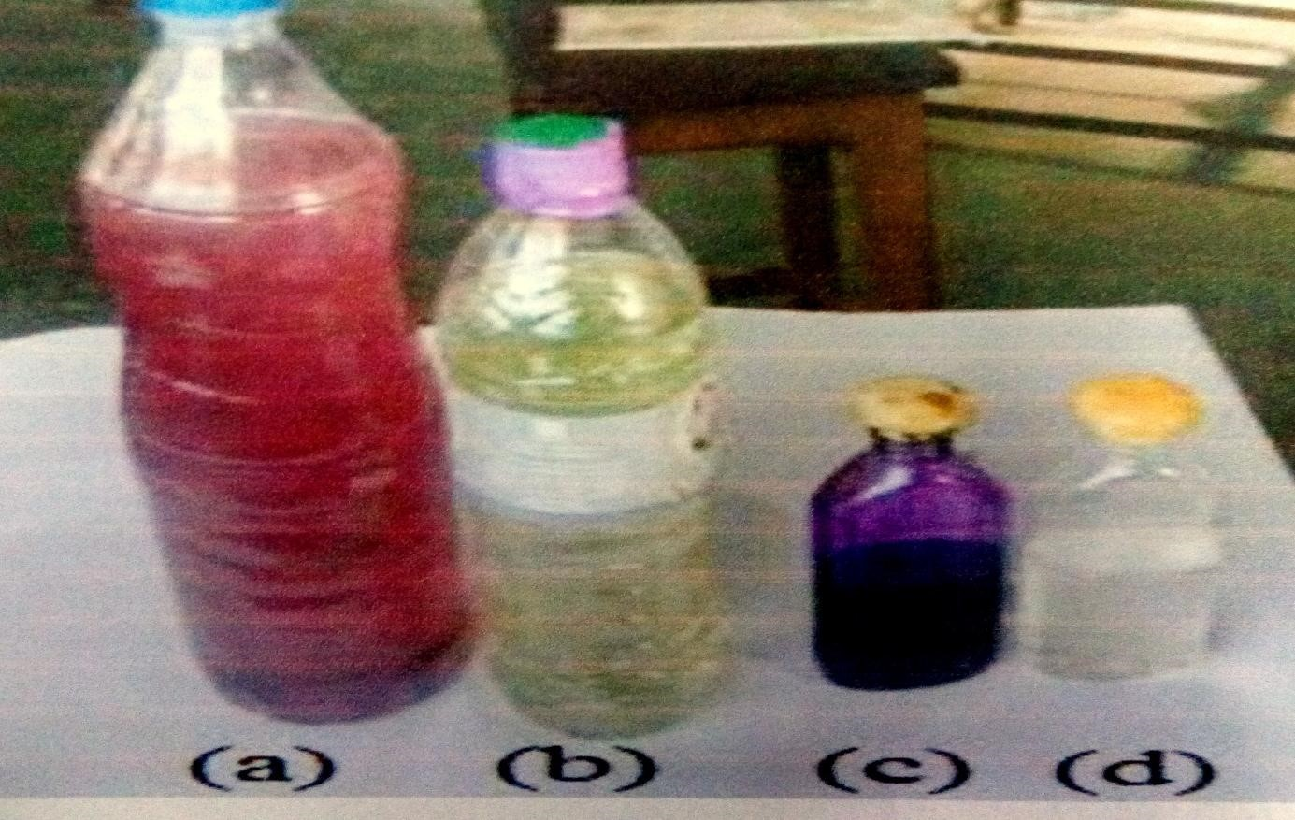

(a)Mixture of Resin, Catalysts and Hardener

(b)Resin: Unsaturated polyester resin

(c)Catalyst: methyl ethyl ketone peroxide

(d) Hardener: Cobalt Napthanate

* Matrix - 97.5% of Unsaturated polyester resin
* Accelerator - 0.5% of Cobalt Napthanate (Hardener)
* Catalyst -2% of Methyl Ethyl Ketone Peroxide(MEKP)

**5.4 COMPOSITE PANEL MAKING:**

**Panel preparation:**

In mould preparation the resin is mixed with hardener in the ratio of 4:1. The mixed is strewed with stirrer for 15 minutes continuously.

**5.4.1 Pattern:**

Pattern for panel

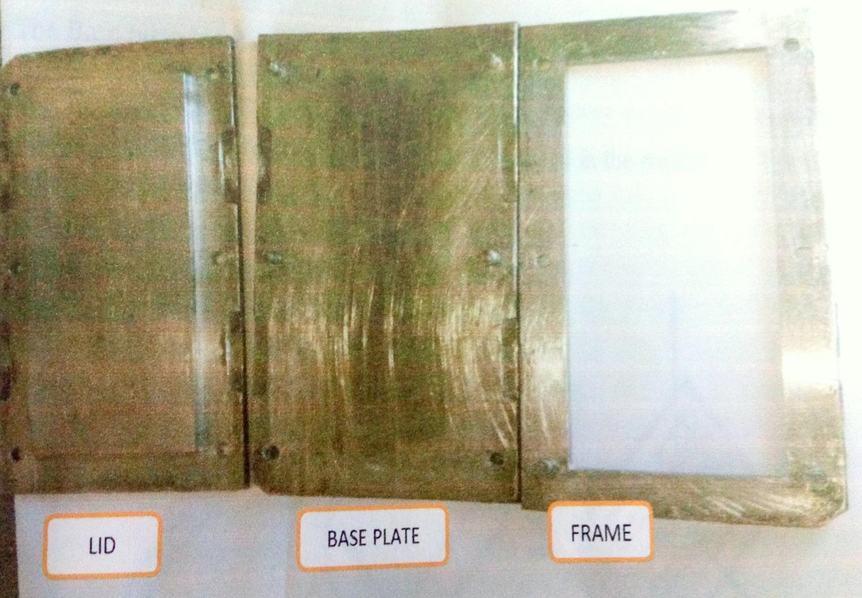

* LID- It is the upper part of the die in the pattern molding.
* BASE PLATE- It is the lower part of the die in the pattern molding.
* FRAME- It is the middle part of die in the pattern molding. In certain

Cap. We getting of our product or work done in space.

The pattern is designed by as per ASTM standard. The pattern is made up of mild steel. The pattern size is 300 mm × 125 mm × 8 mm (ASTM D37-08). The pattern consist of three parts.

The Base plate is very thin plate which is placed inside the inner plate. The LID is placed on the top of the inner plate. The main purpose of the lid is to apply an evenly distributed load on the mixture which is filled in the pattern.

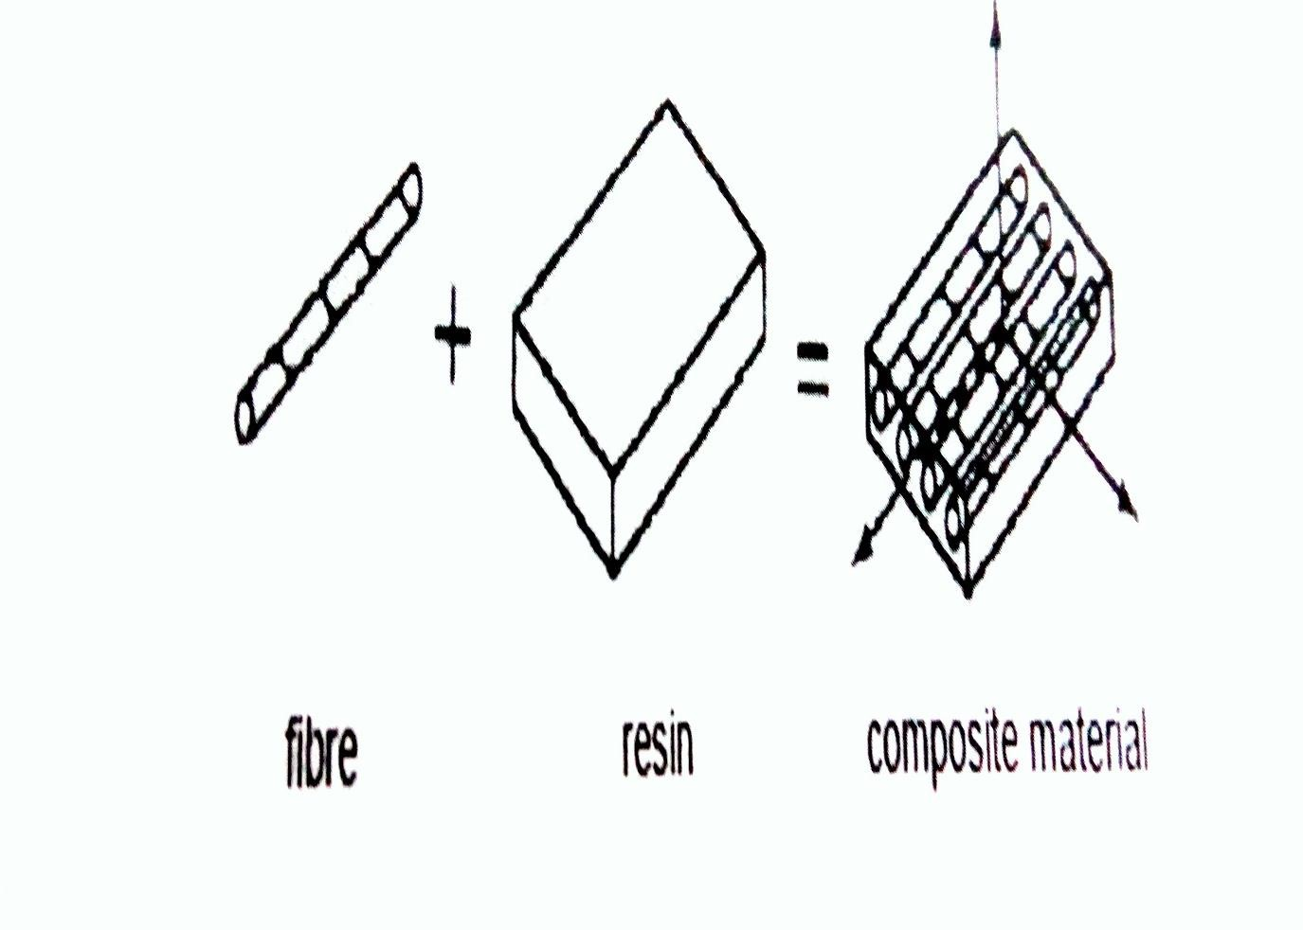

**5.4.2 SPECIMEN MANUFACTURING:**

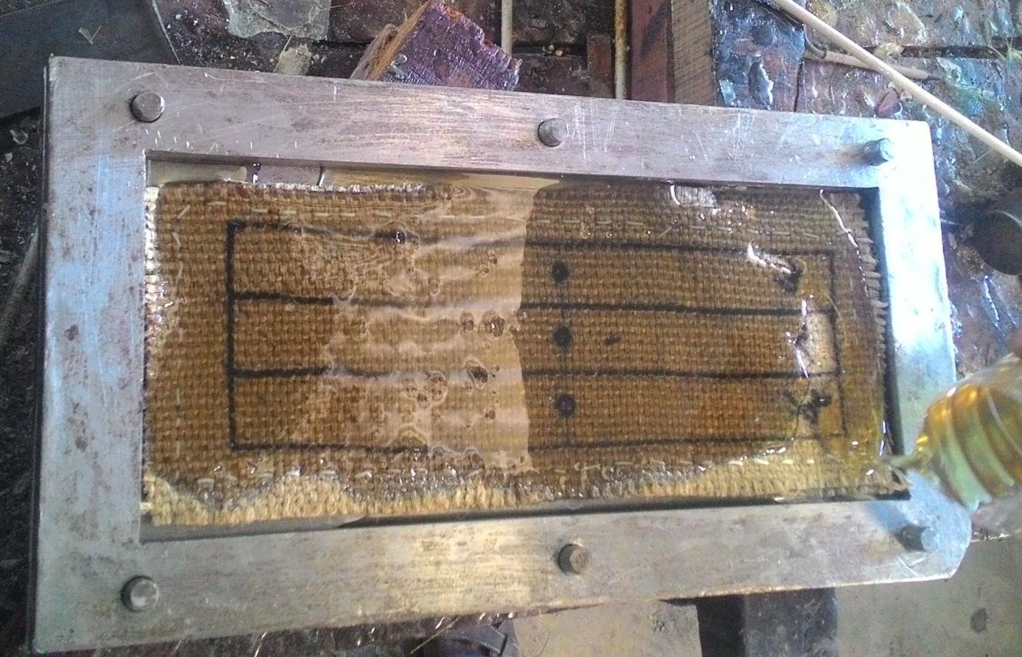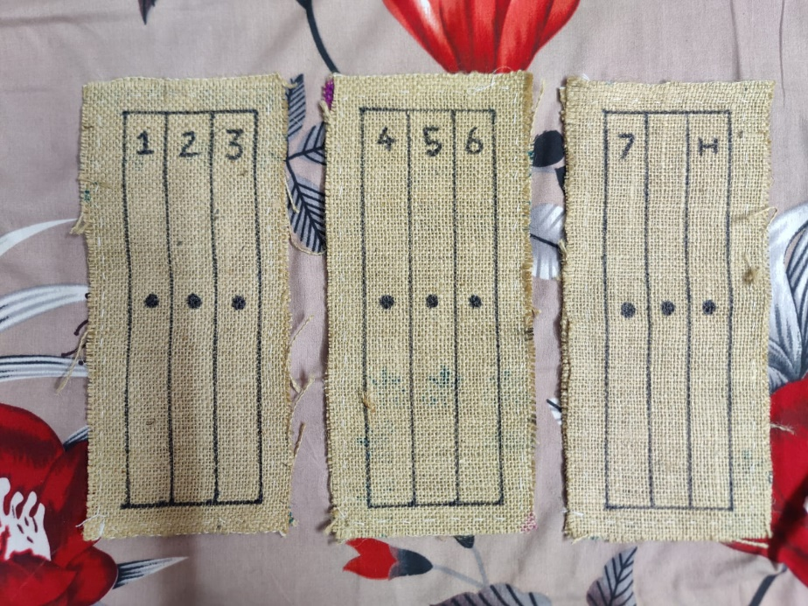

## **5.4.3 Compression Molding Machine**

**PROCESS**

Composites are formed by placing fibers impregnated in resin onto a female mould and applying pressure using a male mould to eliminate any excess resin form the ACM. Compression molding is useful for fabrication of open sections, such as boat hulls.

* The degassed matrix solution was applied on the compressed sheet by using a brush, and air bubbles were removed carefully with a grooved roller
* The mould was closed, and pressure was until complete closure and kept under pressure for 48hrs.
* The composite plates were prepared for fiber length mentioned above

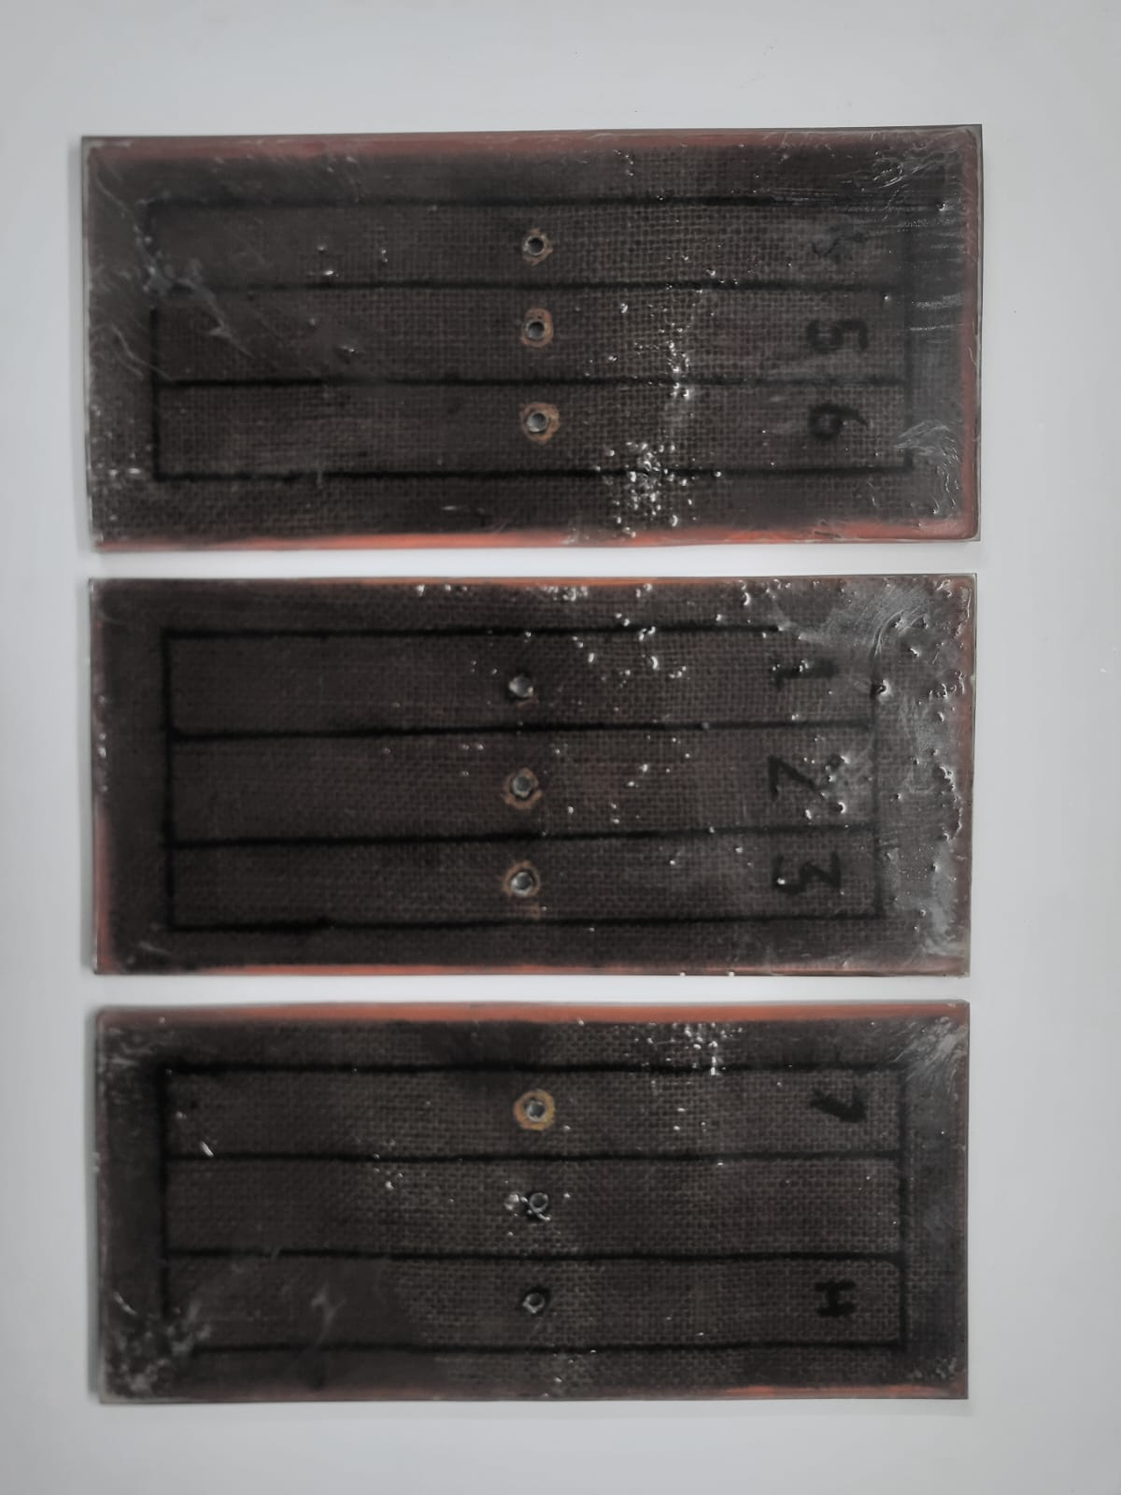**Final Stage:**

**5.4.5 Testing Dimension:**

As per the ASTM standard specimen dimensions are follows

**Flexural Test (D 790) - 125×12.7×8**

*All dimensions are in mm*

**5.4.6 Drilling the specimen:**

Drilling is a cutting process that uses a drill bit to cut or enlarge a hole of circular cross section. The drill bit is rotary cutting tool, often multipoint the bit pressed against the work piece and rotated at rates of hundreds to thousands of revolution per minute. The forces and cutting edges against the work piece, chip were exists. Here we using of low speed to drill the work piece because of light materials. And we using vertical drilling machine to done for our work.

**Drill Bit Size : 6 mm diameter**

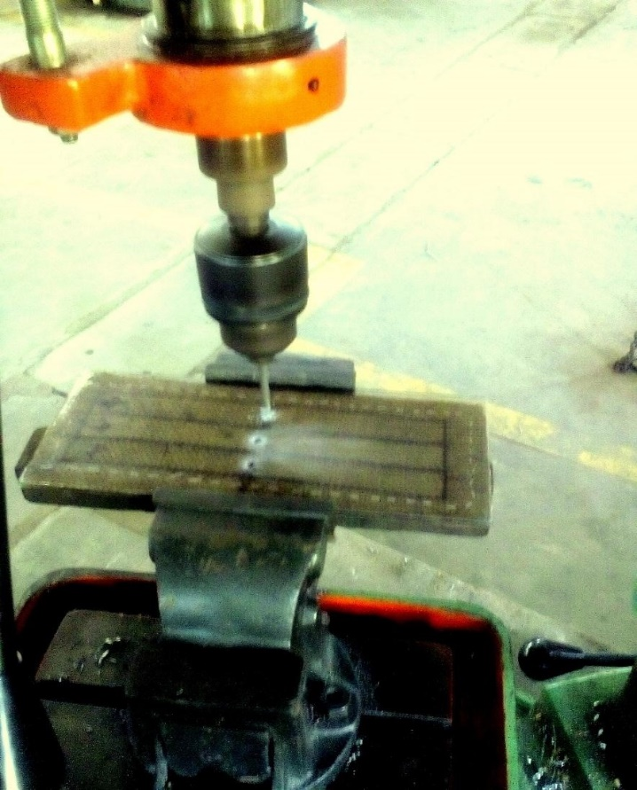

### **5.4.7 FLEXURAL TESTING MACHINE:**

**SPECIFICATIONS:**

Machine Name : Tensile testing machine

Testing load range : Max 5 Ton

Make : Associated Scientific Eng.

Works, New Delhi

Digital Encoder make : Auto Instruments - Kolhapur

Gear rotation speed (for gradual loading) :1.25. 1.5 & 2.5 mm /min

Software details : FIE make India

**CHAPTER 6**

**EXPERIMENT**

1. Flexural test was conducted as per ASTM D 790. Specimens of were cut from the laminate such that the jute warp yarns oriented along the length of the specimen.
2. Before loading the specimens in the machine, the computer system connected to the machine was set up by inputting the necessary information of gauge length and width of the specimen.
3. The computer system was then prepared to record data and output necessary load-deflection graphs Aluminium end tabs were bonded to the specimen for proper gripping.
4. Specimens were loaded in three point bending with a recommended span to depth ratio of 16:1. The test was conducted on the universal testing machine using a load cell of 10kN rate of loading.
5. The specimens were loaded into the machine, and a flexural test was performed. The data was recorded electronically in text file and the load deflection curve.
6. The test process involves placing the test specimen in the testing machine and slowly extending it until it fractures.
7. During this process, the elongation of gauge section is recorded against the applied force.
8. The data is manipulated so that it is not specific to t e geometry of the test sample.

**CHAPTER 7**

**STRESS CONCENTRATION**

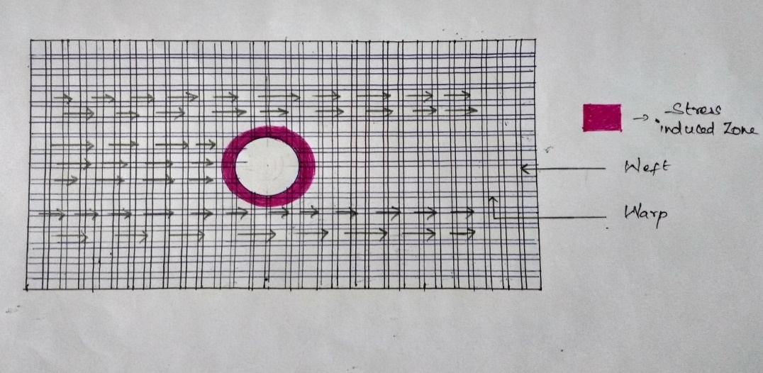**7.1 BEFORE STITCHING:**

**Fig.7.1 – Schematic diagram of specimen before stitching**

The figure 7.1 shows the stress induced zone around the hole in the composite. The fiber along the horizontal direction of woven jute/polyester specimen is called as WARP. It is the load carrying element. The fiber along the vertical direction of woven jute/polyester specimen is called as WEFT. It is the load distributing element.

Due to the breakage in the load transmission path in the specimen, the load cannot be transmitted to other end.so, the stress concentration is induced around the hole.

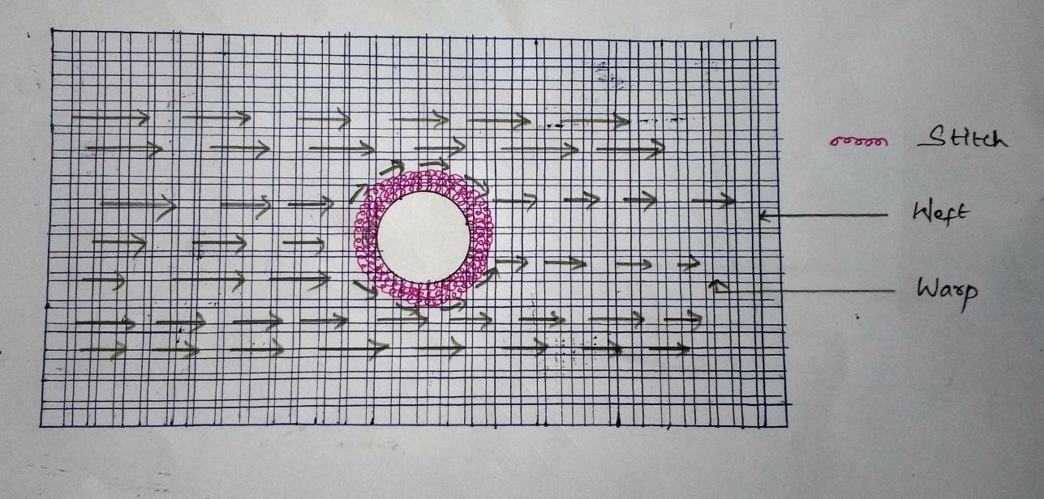**7.2 AFTER STITCHING:**

## **Fig.7.2 – Schematic diagram of specimen after stitching**

The figure 7.2 shows the stitch is made around the hole to form a bridge for transmitting the load to other end. The stitch neglects the breakage and reduces the stress. It is done by distributing the stress through stitch.

**CHAPTER 8**

**OBSERVATION**

**8.1 STACKING SEQUENCE**

|  |  |  |  |  |  |
| --- | --- | --- | --- | --- | --- |
| **LAMINATE STACKING SEQUENCE** | | | | |  |
| **SYMBOL** | **STACKING SEQUENCE** | **WEIGHT OF FIBRES (%)** | | **TOTAL FIBRE** | **THICKNESS**  **(mm)** |
| **JUTE** | **POLYESTER** | **WEIGHT FRACTION (%)** |
| **S1** | **JJJJJJJJJJ** | **100** | **00** | **42.6** | **12** |
| **S2** | **PJJJJJJJJP** | **80** | **20** | **42.7** | **12** |
| **S3** | **PPJJJJJJPP** | **60** | **40** | **41.2** | **12** |
| **S4** | **PPPJJJJPPP** | **40** | **60** | **41.9** | **12** |
| **S5** | **JPJPJJPJPJ** | **60** | **40** | **41.2** | **12** |
| **S6** | **PJJPJJPJJP** | **60** | **40** | **41.8** | **12** |
| **S7** | **PJPJPPJPJP** | **40** | **60** | **41.4** | **12** |
| **J – Jute ply , P – Polyester ply** | | | | |  |

**TABLE 8.1 LAMINATE SEQUENCE**

The Experimental investigation of the untreated woven jute and polyester hybrid composites on their flexural properties is studied by varying the stacking sequence of the plies or laminates showed in table 8.1.

The specimens were manufactured by manual lay-up technique in a mould and preserved under light low pressure for 1h, and it is preserved for 48h at room temperature. All the specimens consists a total of 10 plies, by varying the quantity and location of polyester plies so as to obtain seven different combination of plies.

One sample of laminate consisting of all jute plies was also fabricated for purpose of comparison of strength. Total weight fraction of fibre was conserved at 42%. The preparation of samples and testing was carried out according to the norms of ASTM standards.

By studying the results obtained, it is clear that the combination of polyester fibres at the extreme ends improves the flexural properties of composite.

This stacking sequence has greater impact in flexural properties than tensile properties. An overall experimental study between the properties of all combination of laminates indicated that the hybrid composite having polyester plies at the extreme ends on the two sides is the optimum Combination with a good balance between the properties and cost.

**8.2 LOCALIZED HYBRIDIZATION**

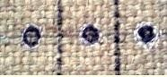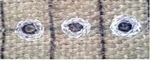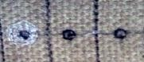

**Fig 8.2 – Specimen with varying stitches**

At first the fibres are arranged and then the dimensions are marked. Now the localised hybridisation process is carried out by stitching around the hole as shown in fig 8.2. There are nine specimens in which one is complete natural and another one is full polyester layer fitted inside the layers.

The specimens are

* Natural – fully jute with no stitch
* S1 – 1 stitch around the hole of diameter 7mm
* S2 - 2 stitch around the hole of diameter 8mm
* S3 – 3 stitch around the hole of diameter 9mm
* S4 – 4 stitch around the hole of diameter 10mm
* S5 – 5 stitch around the hole of diameter 11mm
* S6 – 6 stitch around the hole of diameter 12mm
* S7 – 7 stitch around the hole of diameter 13mm
* Polyester – polyester fibre placed between two natural fibres

After stitching the fibres are mixed with polyester resin and the specimen for testing is made by using manual lay-up technique. Now the drill with the diameter of 6mm is made using drill pit. At last the flexural test is taken with the ASTM standard of D790. The test results are then analysed for comparison.

8.**3 FLEXURAL TESTING**

The ASTM D 790 standard is used for conducting the flexural test. Specimens of 125mm length and 10mm wide were separated from the laminate so that the jute warp yarns are directed towards the length of the specimen. Specimens were loaded under three point restricted bending with a most suitable horizontal span to vertical depth ratio of 16:1 as shown Fig. The test was conducted on the machine which is used for tension test previously using a load cell of 10kn at loading rate. The flexural stress in a three point bending test can be calculated using the following formula

𝝈**max = (3*p*max*l*)/ (**𝒃𝒉𝟐**),**

Where *P*max is the maximum load during failure (N), *L* is the length of span (mm), *b* is the width of the specimen (mm) and *h* is the thickness of the specimen (mm). From the slope of the initial portion of the load-deflection curve the flexural modulus is obtained. Flexural modulus is calculated by using the formula

***E* = (**𝒎𝑳𝟑**) / (**𝟒𝒃𝒉𝟑**),**

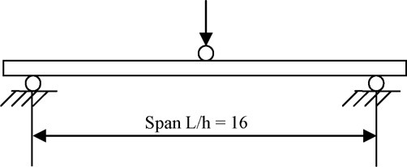 Where m is the initial slope of the load deflection curve. For each stacking sequence, five specimens are tested and average result is obtained.

**Fig 8.3 - Flexural test configuration**

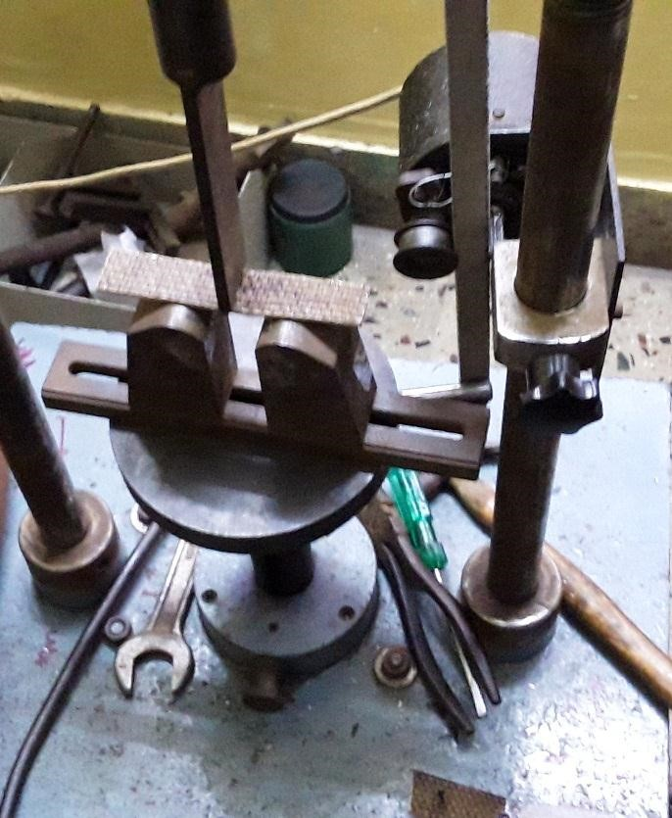

**Fig 8.4 - Flexural testing machine**

The figure 8.4 shows the original setup of the testing.

**CHAPTER 9**

**RESULTS AND DISCUSSION**

**9.1 OBSERVATIONS OF SPECIMEN WITH VARIOUS STACKING SEQUENCE**

The following table shows the variation in displacement of the specimens of stacking sequence by varying the load.

|  |  |  |
| --- | --- | --- |
| **STACKING SEQUENCE** | **LOAD(KN)** | **DISPLACEMENT(mm)** |
| **S1** | **0** | **0** |
| **0.25** | **4** |
| **0.28** | **4.2** |
| **0.3** | **4.5** |
| **0.32** | **4.3** |
| **S2** | **0** | **0** |
| **0.25** | **4.3** |
| **0.28** | **4.5** |
| **0.38** | **4.8** |
| **0.42** | **4.6** |
| **S3** | **0** | **0** |
| **0.25** | **5.2** |
| **0.28** | **5.3** |
| **0.5** | **5.9** |
| **0.53** | **5.7** |

|  |  |  |
| --- | --- | --- |
| **S4** | **0** | **0** |
| **0.25** | **6.6** |
| **0.28** | **6.9** |
| **0.52** | **7** |
| **0.54** | **6.4** |
| **S5** | **0** | **0** |
| **0.25** | **4.2** |
| **0.28** | **4.4** |
| **0.4** | **5** |
| **0.43** | **4.5** |
| **S6** | **0** | **0** |
| **0.25** | **5.2** |
| **0.28** | **5.5** |
| **0.45** | **5.6** |
| **0.48** | **5.1** |
| **S7** | **0** | **0** |
| **0.25** | **4.8** |
| **0.28** | **5** |
| **0.42** | **5.3** |
| **0.44** | **4.6** |

### **9.2 GRAPH: LOAD VS DISPLACEMENT FOR STACKING SEQUENCES**

0

1

2

3

4

5

6

7

8

0

0.1

0.2

0.3

0.4

0.5

0.6

**DISPLACEMENT (mm)**

**LOAD (KN)**

**Stacking Sequence**

s2

S3

S4

S5

S6

S7

s1

The variation of flexural strength corresponding to the stacking sequence diagrams for various hybrid laminate stacking sequences are shown in Fig 9.1. All the curves indicate non-linear behaviour. The starting of the failure is indicated at the point of deviation of linearity and this is mainly caused by the initiation of crack on the tension side. Flexural properties are increased with increase in the polyester fibre content from 0 to 20 and 40% of the total fibre weight.

However, it is also noticed that there is no further increase in flexural properties with the increase in polyester fibre weight to 60% (S4). It is interesting to note that the laminate sequence S6 with polyester fibre weight of 40% has 6.6% higher flexural strength compared to sequence S7 with 60% polyester fibre weight**.**

**9.3 OBSERVATIONS OF SPECIMEN WITH VARYING NUMBER OF STICHES**

0

1

2

3

4

5

6

0

0.1

0.2

0.3

0.4

0.5

0.6

**DISPLACEMENT (mm)**

**LOAD (KN)**

**STICHED SPECIMENS**

natural

stitch 1

stitch 2

stitch 3

stitch 4

stitch 5

stitch 6

stitch 7

polyester

The Load Vs Displacement curve for various number of stitches is shown in the figure . The natural fibre which has no polyester present in it has the lowest strength and hence it has low displacement value. The fully hybridised i.e. the polyester layer placed between the two natural fibres have the maximum strength. The other specimens have displacements corresponding to number of stitches. As the number of stitches increases the displacement of the specimen also increases.

|  |  |  |
| --- | --- | --- |
| **SPECIMEN** | **LOAD(KN)** | **DISPLACEMENMT(mm)** |
| **Full natural** | **0** | **0** |
| **0.19** | **2.7** |
| **0.23** | **3.1** |
| **0.25** | **3.5** |
| **0.28** | **3.3** |
| **Stitch 1** | **0** | **0** |
| **0.19** | **2.9** |
| **0.23** | **3.2** |
| **0.3** | **3.8** |
| **0.33** | **3.6** |
| **Stitch 2** | **0** | **0** |
| **0.19** | **3.1** |
| **0.23** | **3.3** |
| **0.31** | **4** |
| **0.34** | **3.7** |
| **Stitch 3** | **0** | **0** |
| **0.19** | **3.2** |
| **0.23** | **3.5** |
| **0.32** | **4.1** |
| **0.36** | **3.8** |
| **Stitch 4** | **0** | **0** |
| **0.19** | **3.3** |
| **0.23** | **3.6** |
| **0.34** | **4.2** |
| **0.38** | **3.7** |

|  |  |  |
| --- | --- | --- |
| **Stitch 5** | **0** | **0** |
| **0.19** | **3.4** |
| **0.23** | **3.7** |
| **0.35** | **4.3** |
| **0.39** | **3.9** |
| **Stitch 6** | **0** | **0** |
| **0.19** | **3.5** |
| **0.23** | **3.8** |
| **0.37** | **4.5** |
| **0.41** | **4.1** |
| **Stitch 7** | **0** | **0** |
| **0.19** | **3.9** |
| **0.23** | **4.3** |
| **0.39** | **4.7** |
| **0.44** | **4.5** |
| **Polyester layer placed between two natural fibres** | **0** | **0** |
| **0.19** | **4.7** |
| **0.23** | **5** |
| **0.43** | **5.3** |
| **0.49** | **4.9** |

**9.4 WEIGHT FRACTION VS STRENGTH OF STACKING SEQUENCE**

|  |  |  |  |
| --- | --- | --- | --- |
| **STACKING SEQUENCE** | **WEIGHT**  **FRACTION OF FIBRES (%)** | **WEIGHT FRACTION OF POLYESTER (%)** | **FLEXURAL STRENGTH(Mpa)** |
| **S1** | **42.6** | **0** | **120** |
| **S2** | **42.7** | **20** | **135** |
| **S3** | **41.2** | **40** | **155** |
| **S4** | **41.9** | **60** | **158** |
| **S5** | **41.2** | **40** | **136** |
| **S6** | **41.8** | **40** | **154** |
| **S7** | **41.4** | **60** | **146** |

0

20

40

60

80

100

120

140

160

180

S1

S2

S3

S4

SS

S6

S7

**Flexural Strength**

**MPa**

**(**

**Stacking Sequence**

***Flexural Strength***

***(***

***MPa***

***)***

**Fig 9.3 – GRAPH – Flexural strength of stacking sequence**

The figure 9.3 shows the optimum sequence having the higher strength and the values for the flexural strength for different stacking sequences.

**9.5 WEIGHT FRACTION VS STRENGTH OF STITCHED SPECIMENS**

|  |  |  |  |
| --- | --- | --- | --- |
| **SPECIMEN** | **WEIGHT**  **FRACTION OF FIBRES (%)** | **WEIGHT**  **FRACTION OF**  **POLYESTER (%)** | **FLEXURAL STRENGTH(Mpa)** |
| **Full natural** | **40.5** | **0** | **115** |
| **Stitch 1** | **40.7** | **3** | **124.5** |
| **Stitch 2** | **40.9** | **3.2** | **125.8** |
| **Stitch 3** | **41.1** | **3.7** | **127.5** |
| **Stitch 4** | **41.3** | **3.9** | **128.7** |
| **Stitch 5** | **41.5** | **4.2** | **130** |
| **Stitch 6** | **41.6** | **4.5** | **131.5** |
| **Stitch 7** | **41.8** | **4.8** | **133** |
| **Polyester layer placed**  **between two natural fibres** | **45.2** | **20** | **145** |

**Fig.9.5 – GRAPH – Weight of Polyester Vs Strength**

**9**

**COMPARISON**

**.6**

0

1

2

3

4

5

6

0

0.1

0.2

0.3

0.4

0.5

**DISPLACEMENT (mm)**

**LOAD (KN)**

**Comparison**

s2

stitch 7



0

,

115

3

,

124.5

3.2

,

125.8

3.7

,

127.5

3.9

,

128.7

4.2

,

130

4.5

,

131.5

4.8

,

133

114

116

118

120

122

124

126

128

130

132

134

0

1

2

3

4

5

6

**Flexural Strength (MPa)**

**Weight of Polyester (%)**

**Strength Vs Weight Of Polyester**

At first the natural fiber is not stitched and tested. The fig 9.5 shows the relation between weight of polyester and flexural strength. When the weight percentage of the polyester is increased by stitching the strength of the polyester is increased gradually and when the content of polyester is further increased the strength increases.

133

,

4.8

135

,

20

0

5

10

15

20

25

110

115

120

125

130

135

140

**WEIGHT OF POLYESTER (%)**

**FLEXURAL STRENGTH (Mpa)**

**Comparison**

stitch

Stacking sequence

## **Fig 9.7 – GRAPH – comparison of polyester content for same strength between stitch and stacking sequence**

The figure shows the comparison of the weight fraction of polyester for the same strength. The stitch 7 specimen have flexural strength of 133 Mpa and the stacking sequence 2 have the flexural strength as 135 Mpa . But the weight of polyester in stitched specimen (4.8%) is very much lower than the s2 specimen (20%).

**CHAPTER 10**

**CONCLUSION**

Fabricated composite materials considerably reduces the artificial fibers making it environment friendly. The stitch is made around the hole to form a bridge for transmitting the load to other end. The stitch neglects the breakage and reduces the stress. It is done by distributing the stress through stitch. The strength of the specimens of various stacking sequence is tested for the comparison of the same with the stitched one. From all our observations we came to know that the localized hybridized material is nearly equal to the fully hybridized material.in order to see the approximate value we made eight stitches on partly hybridized material. The fatigue property of the specimen with stitches is increased as compared to non-stitched composite. Finally from our observations we came to know that the strength of the seventh stitch is approximately equal to the stacking sequence 2. Hence it is proved that the composite with localized hybridization technique having synthetic fiber content of 3% has equal strength to the composite having synthetic fiber content of 20%. The hybrid composite with localized hybridization in stress concentration area can be effectively used in structural applications.

**CHAPTER 11**

**REFERENCE**

1. **DIPA RAY, B K SARKAR, A K RANA and N R BOSE,** Effect of alkali treated jute fibres on composite properties, bull. Mater. Sci., Vol. 24, No. 2, April 2001, pp. 129–135. © Indian Academy of Sciences.

2. **VIVEK MISHRA, SANDHYARANI BISWAS**, Physical and

Mechanical Properties of Bi-directional Jute Fiber epoxy Composites, Procedia Engineering 51 (2013) 561 – 566.

3. **M. RAMESH, K. PALANIKUMAR, K. HEMACHANDRA REDDY**,

Mechanical property evaluation of sisal–jute–glass fiber reinforced polyester composites, Composites: Part B 48 (2013) 1–9

4. **K. SABEEL AHMEDA, S. VIJAYARANGAN *,*** Tensile, flexural and interlaminar shear properties of woven Jute and jute-glass fabric reinforced polyester composites **,** journal of materials processing technology 2 0 7 ( 2 0 0 8 ) 330–335

5. **V. NANTHAGOPAL, T. SENTHILRAM AND V. R. GIRI DEV**,

Flexural and Impact studies on stitched Self reinforced polypropylene composites.

6. **Arief Yudhanto, Naoyuki Watanabe, Yutaka Iwahori, Hikaru Hoshi**, Effect of stitch density on tensile properties and damage mechanisms of stitched carbon/epoxy composites, Composites: Part B 46 (2013) 151–165